**Test Document for L1 basis, Single party, Two Party, Higher Party identification**

Testing for PO: P60105124

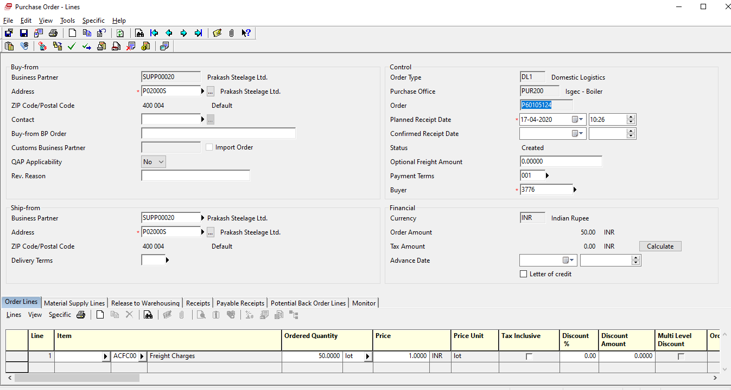

After clicking L1 basic in specific, new session is opened where we set Party type.

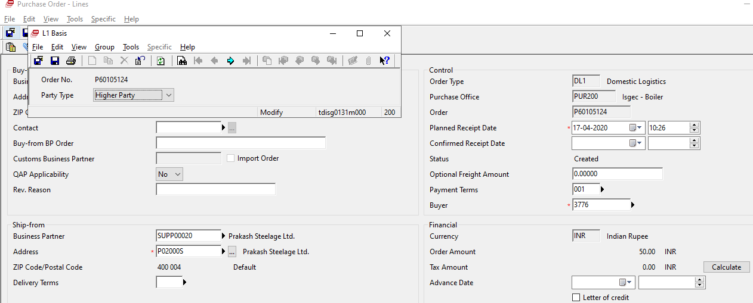

Results are shown in PO:

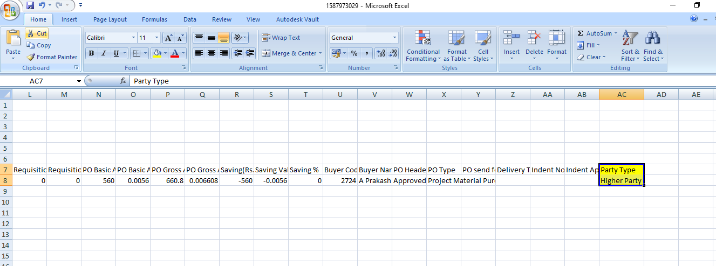

Party Type are shown in Ordering Report for PO and Saving" tdisg4400m200 report.